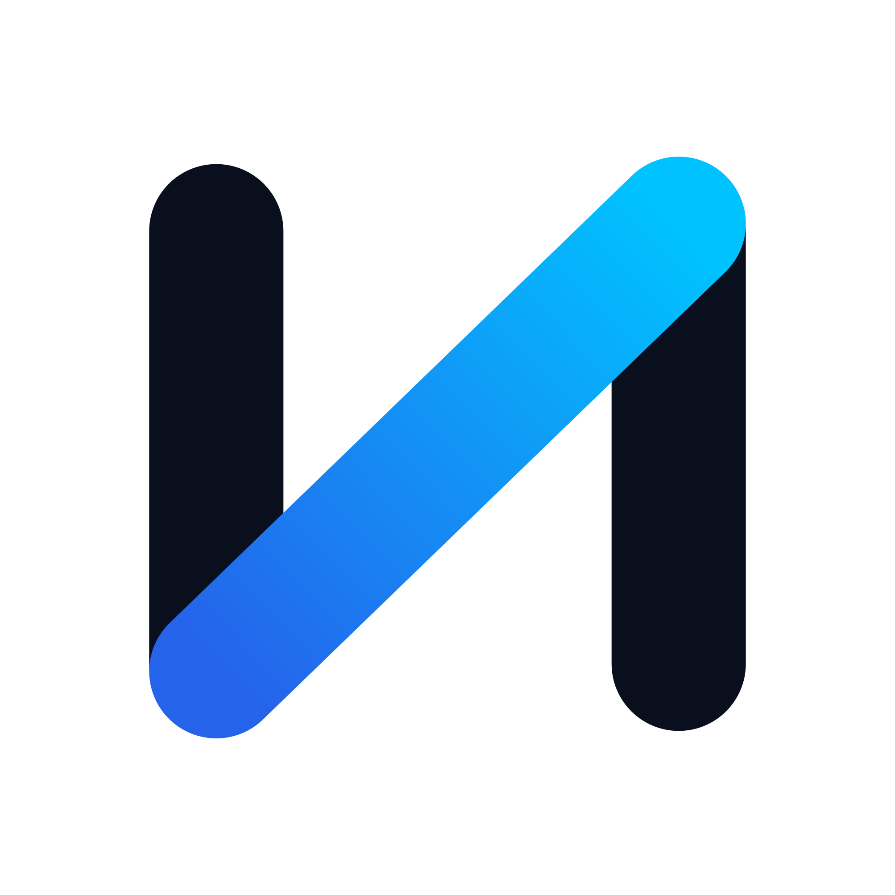
NIAKX
BRAND GUIDE
Build. Launch. Scale.
Version 1.0 · 2026 · AI-powered digital products for modern founders

Contents
01 — Brand Overview
02 — Logo System
03 — Color Palette
04 — Typography
05 — Voice & Tone
06 — Applications & Governance

01 — Brand Overview

Who We Are
NIAKX builds the operating layer for founders who move fast. Our flagship product, NIAKX LaunchKit, compresses the distance between an idea and a live, revenue-generating startup — replacing a stack of disconnected tools and freelancers with a single, AI-powered launch system.
This guide is the single source of truth for how NIAKX looks, sounds, and feels across every surface — product, marketing, investor materials, and partner co-branding. It exists so that anyone building for NIAKX, internally or externally, can do so with the precision the brand demands.

Positioning
AI-powered digital products for modern founders.
NIAKX sits at the intersection of infrastructure and intelligence: not a template library, not a generic AI wrapper, but a structured system that takes a founder from zero to launched with the judgment of a world-class co-founder built in.

Brand Pillars
- Clarity — Every screen, sentence, and slide earns its place. We remove before we add.
- Velocity — We are built for founders racing the clock. Speed is a feature, not a side effect.
- Intelligence — AI is the engine, not the marketing. It should make founders feel capable, never replaced.
- Craft — Premium is a discipline. Every pixel, word, and interaction reflects the standard our customers are trying to reach.

02 — Logo System

Primary Logo
The primary lockup pairs the N symbol with the NIAKX wordmark, set in Space Grotesk Bold with wide tracking. Use this version whenever there is enough horizontal space and a light background.

Primary logo — full color, on white.

N Symbol
The N symbol is an abstract monogram: two structural bars anchor the mark while a rising diagonal — rendered in the Signal Blue → Ion Cyan gradient — reads as trajectory and momentum. It is the compressed expression of “Build. Launch. Scale.” and the only element that should ever be used alone (app icons, favicons, social avatars, loading states).

N symbol — standalone mark.

Light Version
For dark backgrounds, product UI in dark mode, and photography: the wordmark and bars invert to white, while the diagonal keeps its gradient for brand recognition.
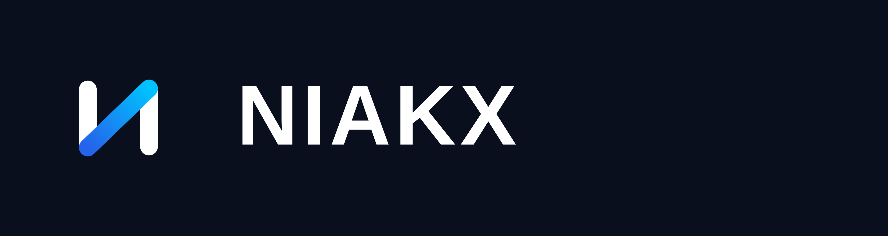
Light (reversed) version — on Void Navy.

Dark Version
A fully monochrome rendering in Void Navy, for single-color print, embossing, engraving, or any context where the gradient cannot reproduce reliably.

Dark (monochrome) version — on white.

Favicon
A simplified, high-contrast tile of the N symbol on a Void Navy rounded square, tuned for legibility at 16–32px (browser tabs, bookmarks, notification icons).
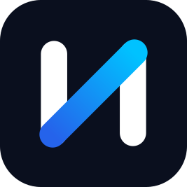
Favicon / app icon tile.

Clearspace & Minimum Size
Maintain clearspace equal to the height of one N-symbol bar on all sides of the logo — no text, icons, or edges may enter this zone. Minimum size is 24px (or 0.25in in print) tall for the symbol alone, and 100px (or 1in) wide for the full lockup, below which the wordmark loses legibility.

Usage Rules
- Do not stretch, skew, or rotate the symbol or wordmark.
- Do not recolor the diagonal gradient — it is a fixed brand asset, not a decorative element.
- Do not add drop shadows, bevels, outlines, or other effects.
- Do not place the full-color or dark logo on backgrounds with insufficient contrast.
- Do not recreate the wordmark in a different typeface, weight, or tracking.
- Do not combine the symbol with a second logo, badge, or partner mark without approved co-branding spacing.

03 — Color Palette
NIAKX color is built for high-contrast, dark-first product surfaces with a precise electric accent — closer to a flight instrument panel than a consumer app. One color leads, one accents, the rest support.
Swatch | Name | Hex | Usage
 | Void Navy | #0A0F1E | Primary background. The default canvas for dark-mode product, decks, and the website.
 | Signal Blue | #2563EB | Primary brand color. Buttons, links, active states, the base of the gradient accent.
 | Ion Cyan | #00C2FF | High-energy accent. Gradient endpoint, highlights, data visualization, hover states.
 | Pure White | #FFFFFF | Reversed text and iconography on dark surfaces; light-mode background.
 | Slate Surface | #1F1F2E | Secondary dark surface — cards, panels, and modals layered above Void Navy.
 | Fog Grey | #94A3B8 | Muted text, borders, dividers, and secondary/disabled UI states.

Usage Ratios
Apply an approximate 60 / 30 / 10 split: Void Navy carries 60% of any surface as the dominant background; Slate Surface and Fog Grey together cover 30% as structure and secondary content; Signal Blue and Ion Cyan are reserved for the remaining 10% — the moments that should draw the eye (primary actions, key metrics, the logo).

Accessibility
Pure White text on Void Navy or Slate Surface exceeds WCAG AA for body copy. Signal Blue on Void Navy passes AA for large text and UI components; for small body text on dark surfaces, default to Pure White or Fog Grey instead of Signal Blue.

04 — Typography
Two typefaces carry the entire system. Space Grotesk gives NIAKX its technical, slightly architectural personality at display sizes. Inter handles everything that needs to be read quickly and precisely — body copy, UI, tables, documentation.

Typefaces
- Space Grotesk — Headlines, product name, section titles, pull quotes, slide titles. Use Medium (500) for most headings and Bold (700) for hero moments and the wordmark.
- Inter — Body copy, UI labels, forms, tables, captions, and all long-form documentation. Use Regular (400) for body, Medium (500) for emphasis and labels, Semibold (600) for buttons and short UI strings.

Type Scale
Role | Typeface | Weight | Size/Line | Case
Display / H1 | Space Grotesk | Bold (700) | 48 / 56 | Sentence case
H2 | Space Grotesk | Bold (700) | 36 / 44 | Sentence case
H3 | Space Grotesk | Medium (500) | 28 / 36 | Sentence case
H4 / Overline | Space Grotesk | Medium (500) | 14 / 20 | UPPERCASE, tracked
Body Large | Inter | Regular (400) | 18 / 28 | Sentence case
Body | Inter | Regular (400) | 16 / 24 | Sentence case
UI Label / Button | Inter | Semibold (600) | 14 / 20 | Sentence case
Caption | Inter | Regular (400) | 13 / 18 | Sentence case

Pairing Rules
- Never set body copy in Space Grotesk beyond a single short line — it is a display face and loses legibility at paragraph sizes.
- Never set headlines in Inter when Space Grotesk is available — headlines are where the brand's technical character shows.
- Use generous tracking (40–60) on the NIAKX wordmark and uppercase overlines only; body text stays at default tracking.

05 — Voice & Tone
NIAKX writes the way a sharp, technical co-founder talks: direct, confident, and allergic to filler. We explain the mechanism, not just the outcome, and we never oversell what the product hasn't earned yet.
Trait | We say | We avoid
Confident | “LaunchKit ships your MVP in days.” | “We think LaunchKit could maybe help you launch faster.”
Precise | “Generate a positioning doc, pitch deck, and landing page from one brief.” | “Our powerful AI does amazing things for your startup.”
Human | “You already know your market. We handle the busywork.” | “Leveraging synergistic AI to actualize your vision.”
Forward-looking | “Built for the founder who scales past the first launch.” | “The ultimate one-stop-shop for absolutely everything.”

Writing Principles
- Lead with the mechanism: say what the product does before what it feels like.
- Prefer active voice and short sentences; cut adjectives that don't carry information.
- Numbers and specifics beat superlatives — “20 slides in one prompt” beats “incredibly fast.”
- Speak to founders as peers, not prospects — no false urgency, no hype-cycle buzzwords.

06 — Applications & Governance

Where This System Applies
- Product UI — light and dark modes, using the color ratios and type scale defined above.
- Marketing — website, landing pages, paid social, and email, always anchored on Void Navy or Pure White.
- Investor & Partner Materials — pitch decks, one-pagers, and data rooms using the Primary or Light logo lockups.
- Social & Community — the N symbol alone as avatar; Signal Blue → Ion Cyan gradient reserved for key visual moments, not backgrounds.

Ownership
This guide is maintained by the NIAKX brand team. Proposed exceptions (new color, new typeface pairing, third-party co-branding) require sign-off before use in any customer-facing surface.
Version | Date | Notes
1.0 | 2026 | Initial brand system: logo suite, color palette, typography, voice & tone.

